**CONDUCTED WORLD ENVIRONMENAL DAY ON 5-6-2019**

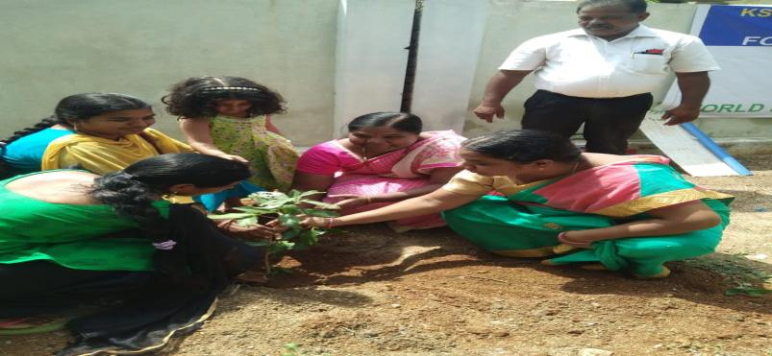

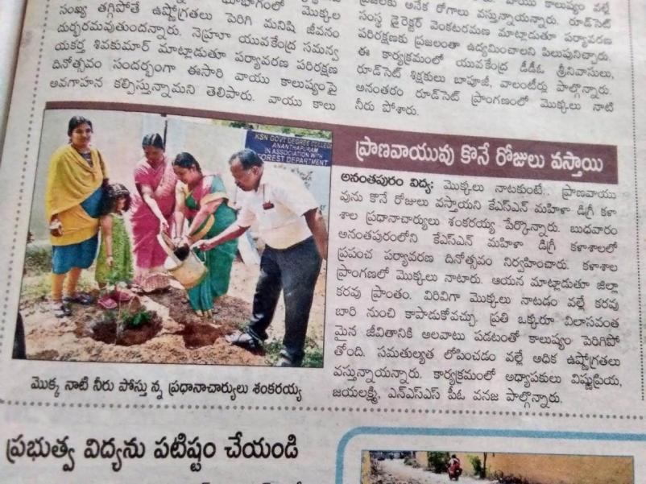

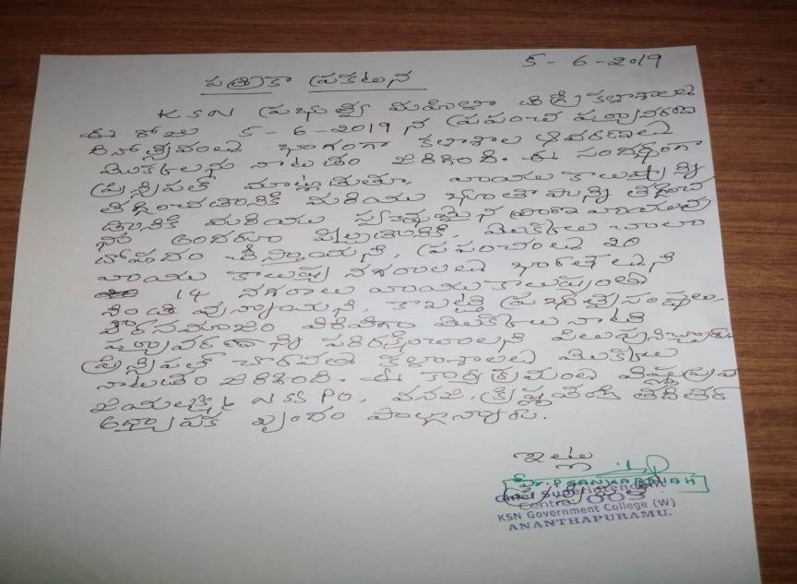

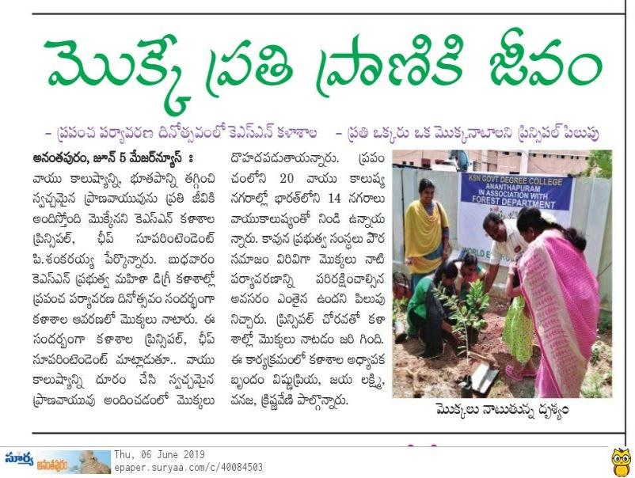

**5 th INTERNATIONAL YOGA DAY CONDUCTED ON 21-6-2019**

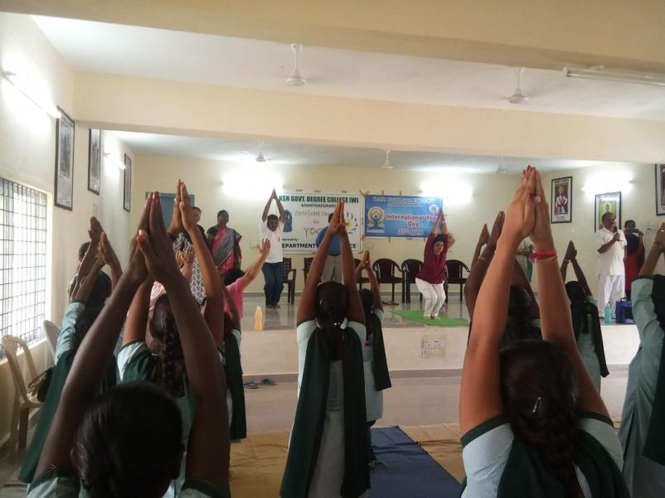

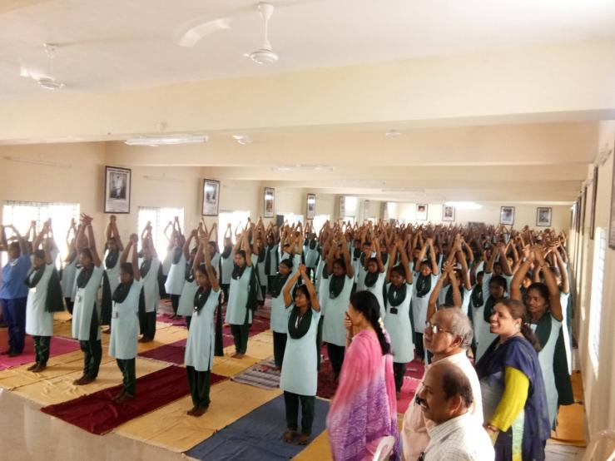

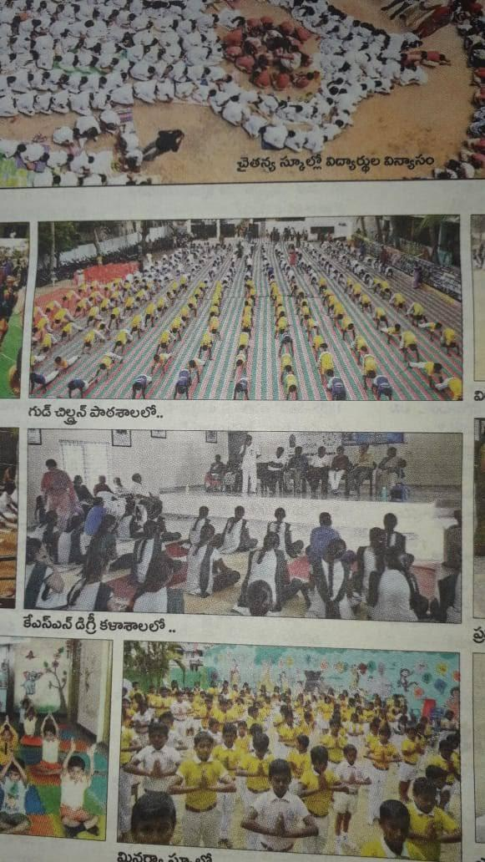

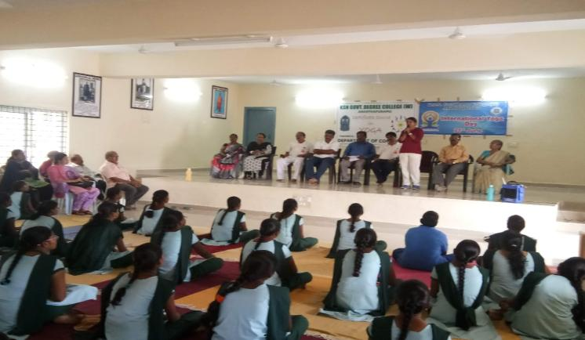

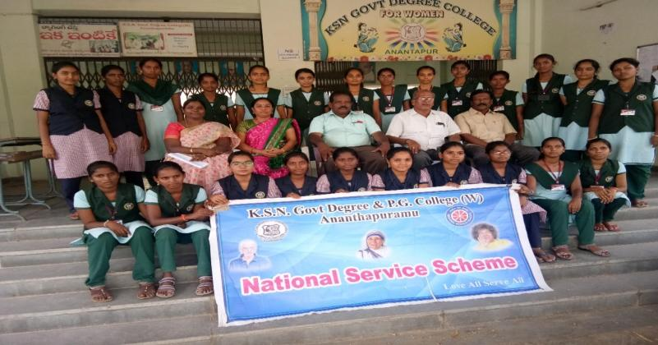**NSS VOLUNTEERS ATTEND NATIONAL INTEGRATION CAMP AT KURNOOL ON 17-7-27-7-2019**

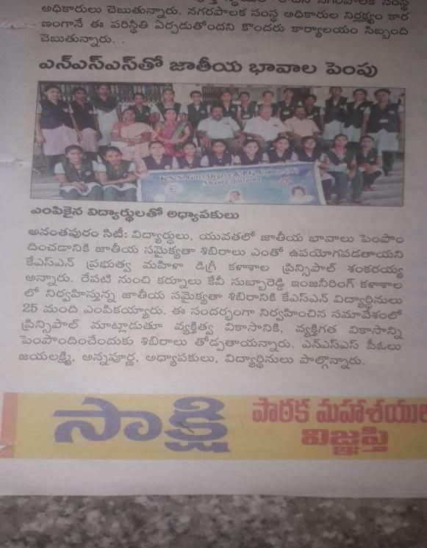

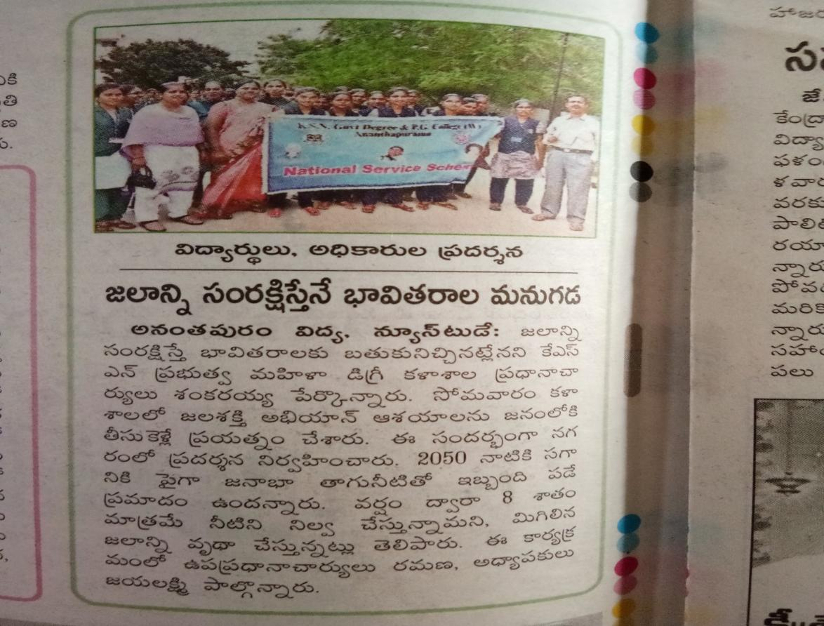

**JALSHAKTHI ABHIYAAN AWARENESS AND RALLY CONDUCTED ON 30-7-2019**

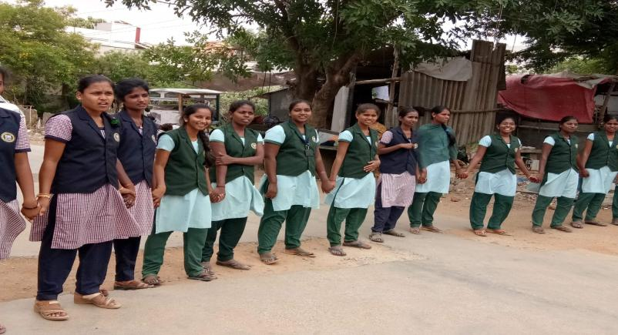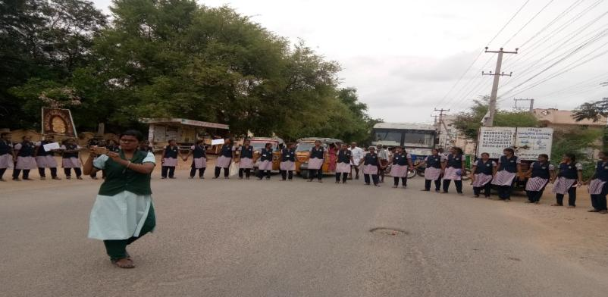

**NSS VOUNTEERS PARTICIPATED IN CULTURAL ACTIVITIES AT LALITHA KALA PARISHAD ON THE OCCASION OF INDEPENDENCE DAY ON 15-8-2019**

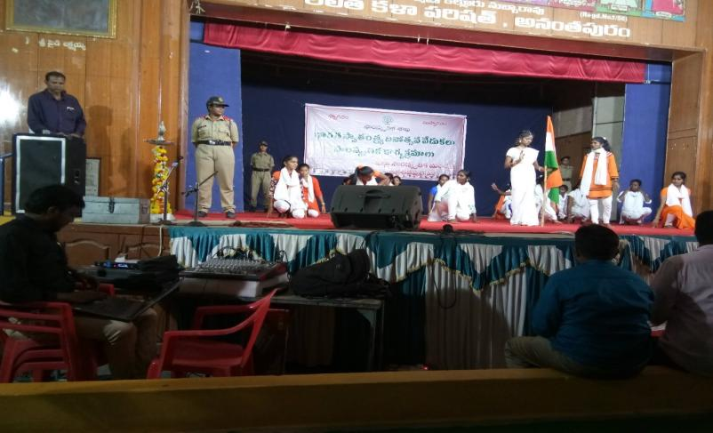

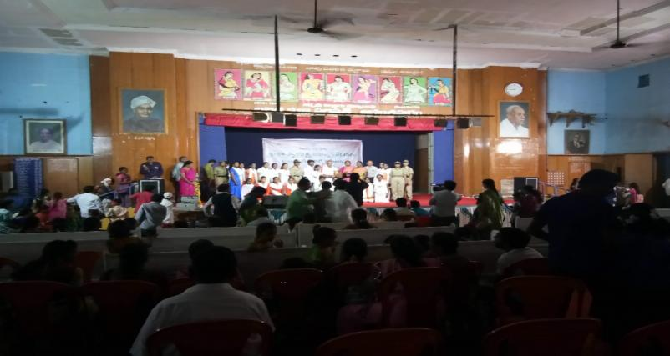

**CHILD OR WOMAN PROTECTION AWARENESS PROGRAM CONDUCTED ON 16-8-2019.**

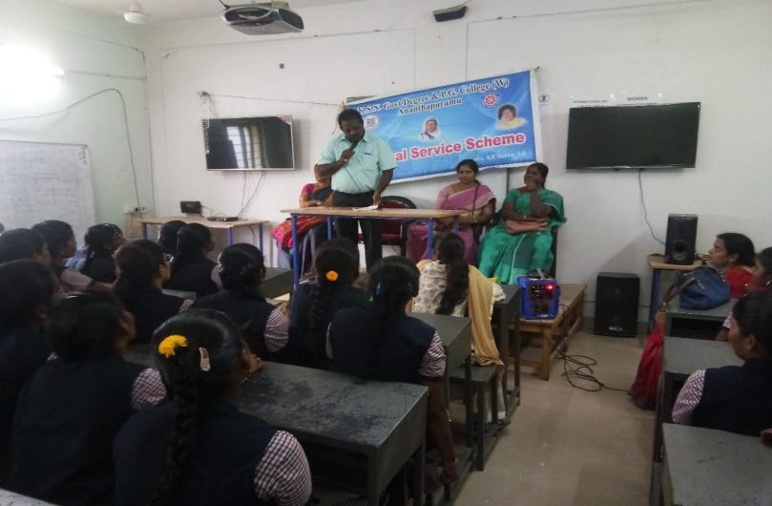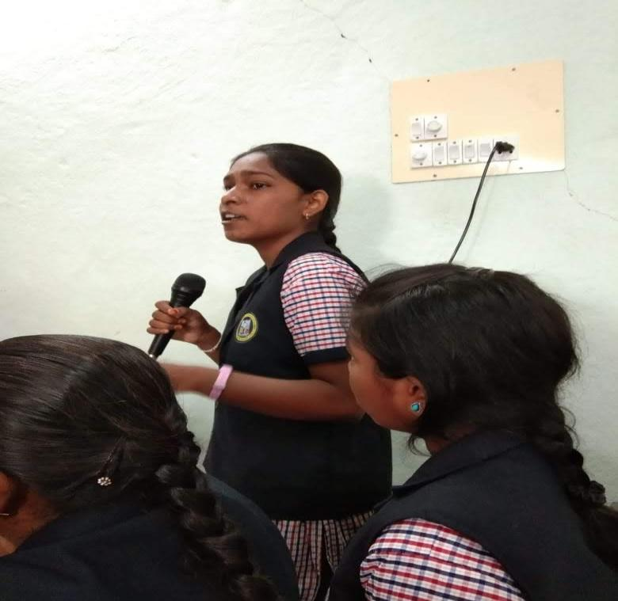

**PLANTATION PROGRAM CONDUCTED IN THE HOSTEL CAMPUS ON 7-9-2019**

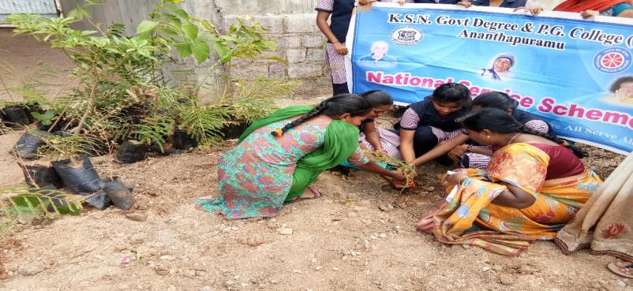

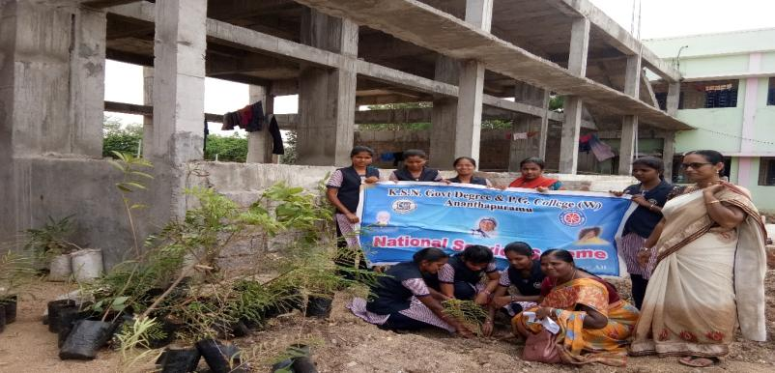

**SWATCH CAMPUS CLEANING ON 17-9-2020 IN ADOPTED VILLAGE,LENIN NAGAR**

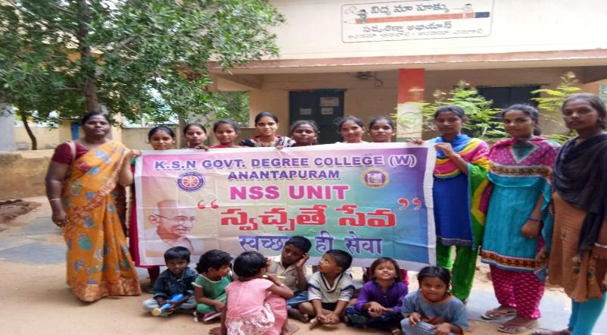

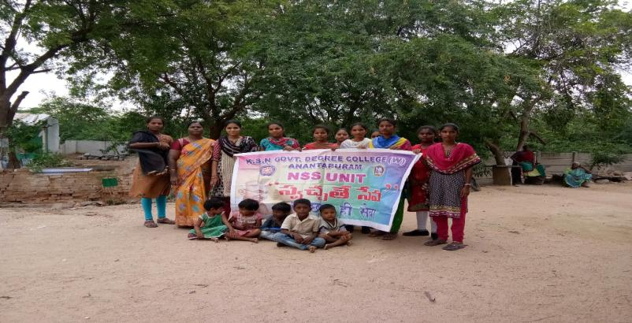

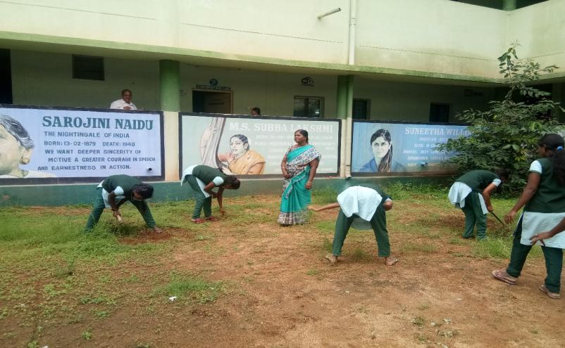

**CAMPUS CLEANING ON 18-9-2019**

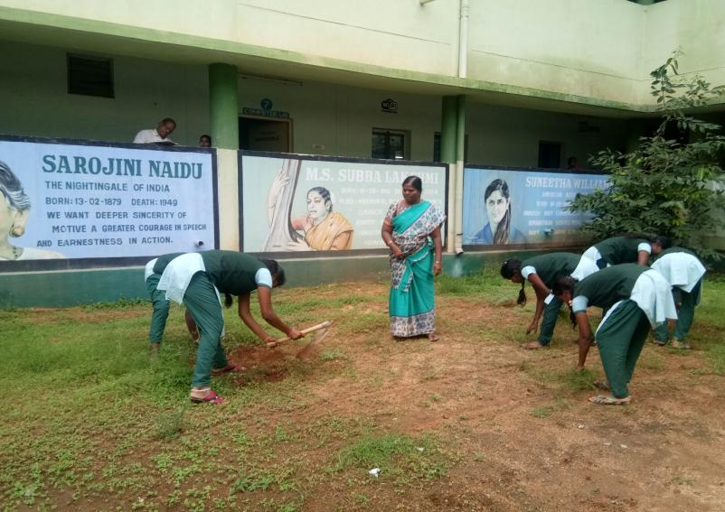

**VANAMAHOSTAVAM 2019 VISITED NSS COORDINATOR CH. VARADACHARYULU GARU AND FOREST DEPARTMENT CONDUCTED ON – 3-9-2019UCT**

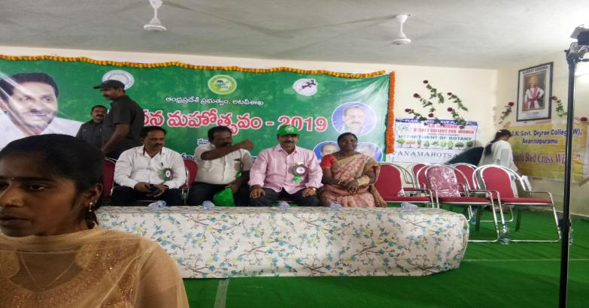

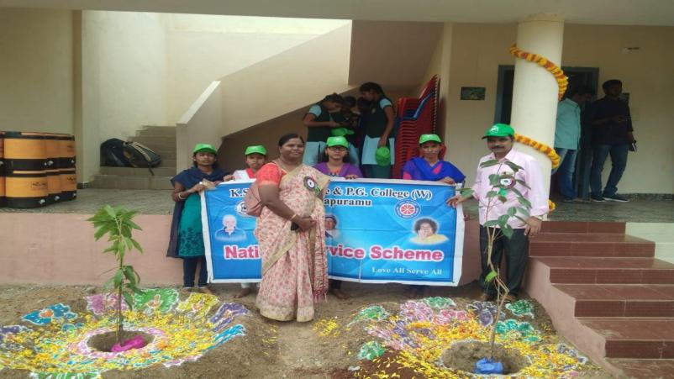

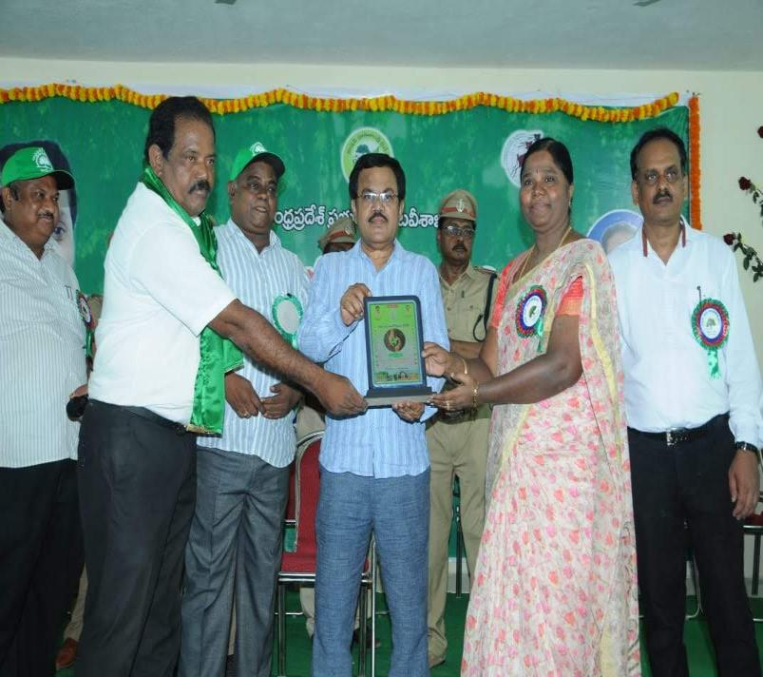

**NSS VOLUNTEERS PARTICIPATED IN DIVISIONAL LEVEL YOUTH FESTIVAL AT GOVERNMENT COLLEGE (MEN)**

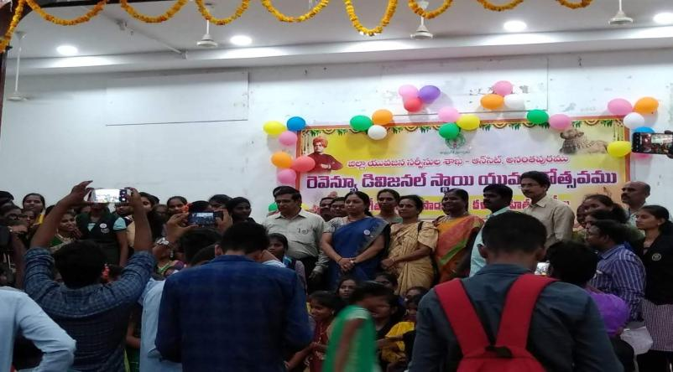

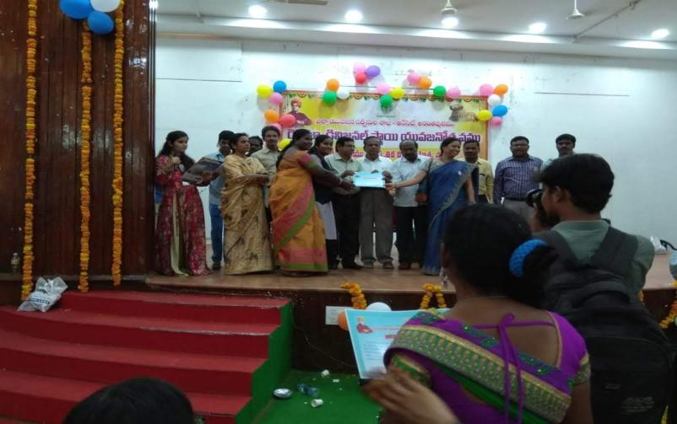

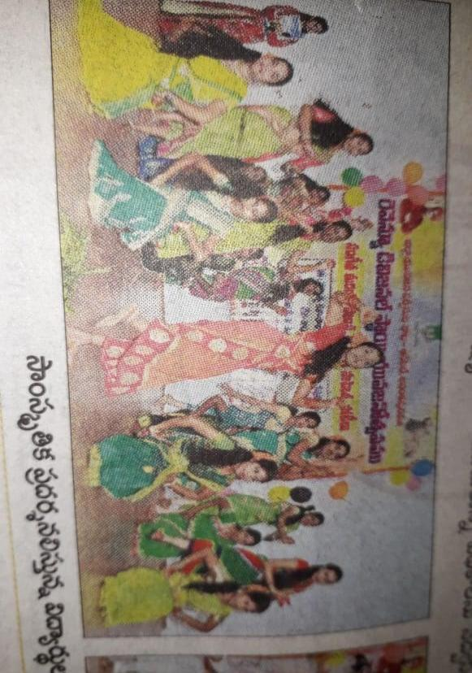

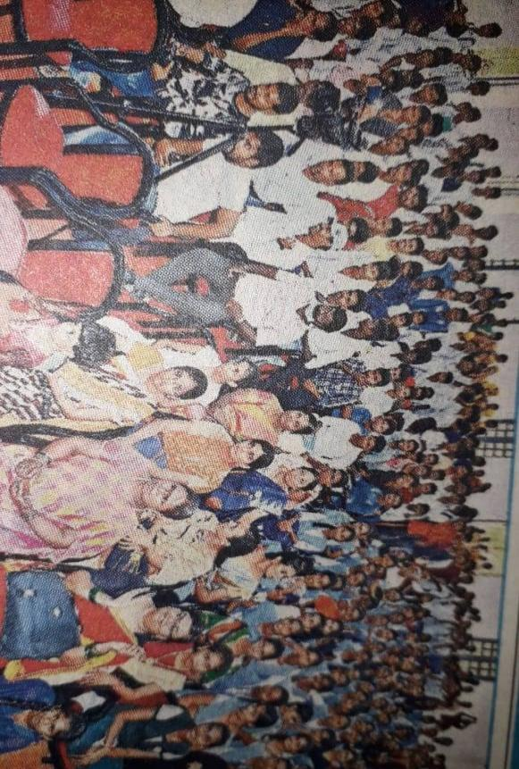

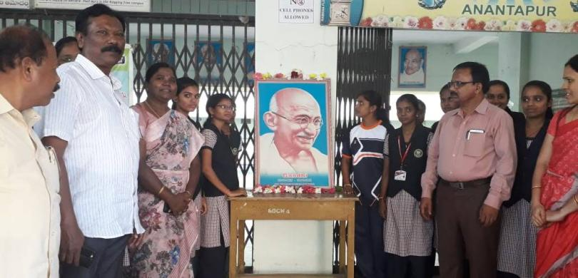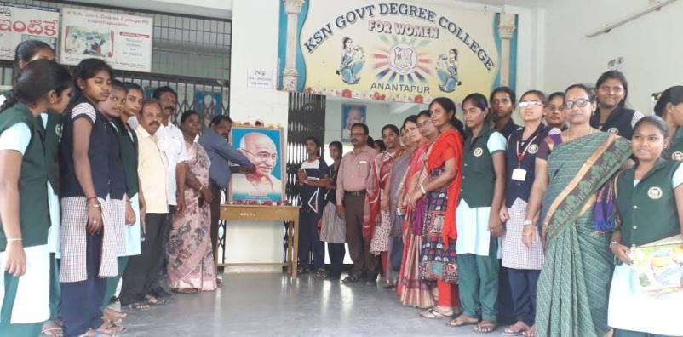 **INTERNATIONAL NON VIOLENCE DAY CONDUCTED AS MAHATHMA GANDHI JAYANTHI DATED ON 2-10-2019**

**NSS VOLUNTEERS PARTICIPATED IN FIT INDIA PROGRAM, ON THE OCCASSION OF MAHATHMA GANDHI JAYANTHI, CHIEF GUEST OF THIS FUNTION IS SATHYA NARAYANA DiSTRICT COLLECTOR ANANTHAPUR, CINDUCTED BY YOUTH WELFARE DEPARTMENT**

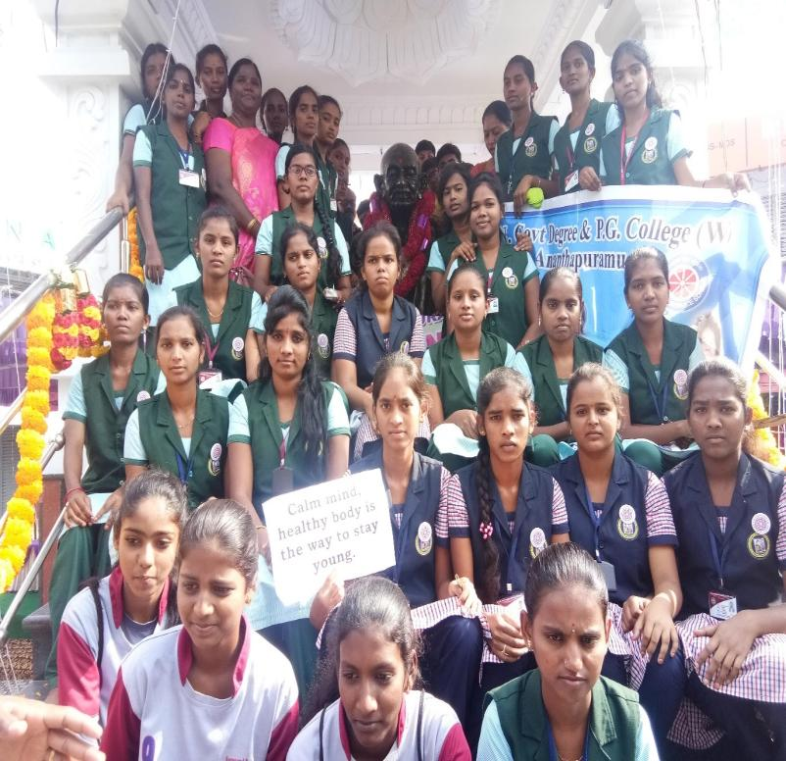

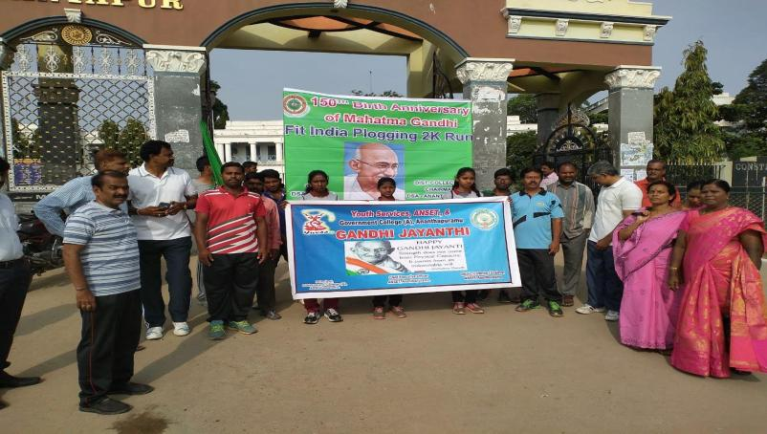

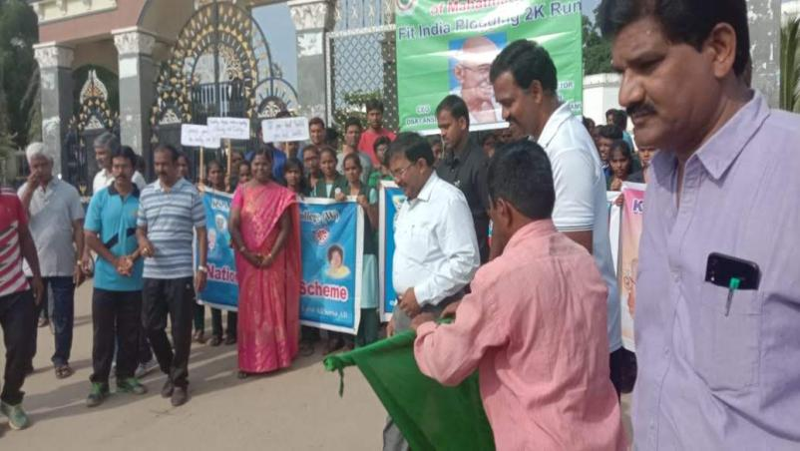

**NSS VOLUNTEERS PARTICIPATED IN FIT INDIA PROGRAM, ON THE OCCASSION OF MAHATHMA GANDHI JAYANTHI, CHIEF GUEST OF THIS FUNTION IS SATHYA NARAYANA DiSTRICT COLLECTOR ANANTHAPUR, CINDUCTED BY YOUTH WELFARE DEPARTMENT**

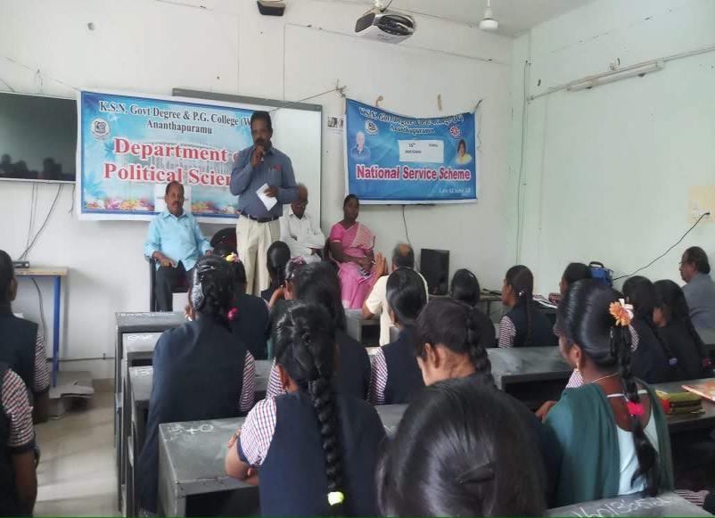

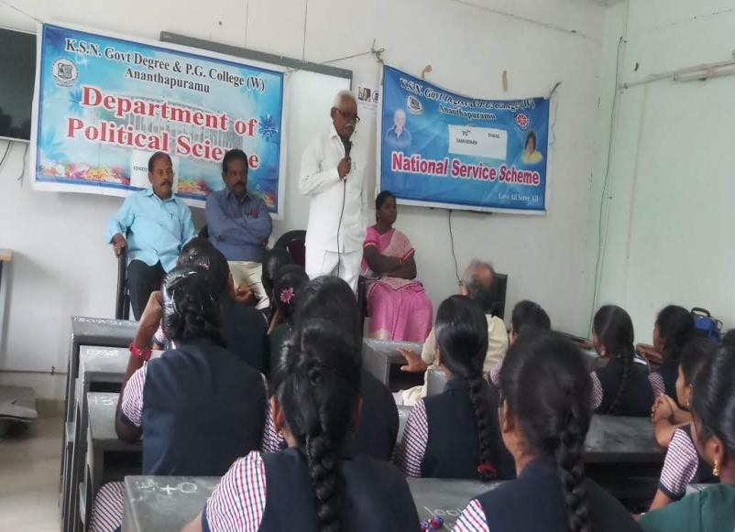

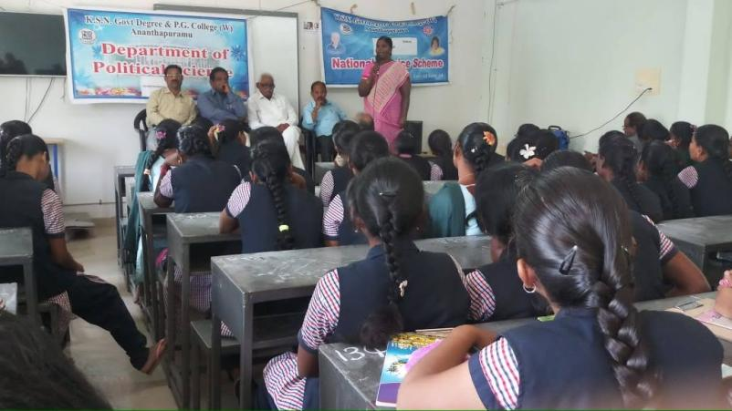

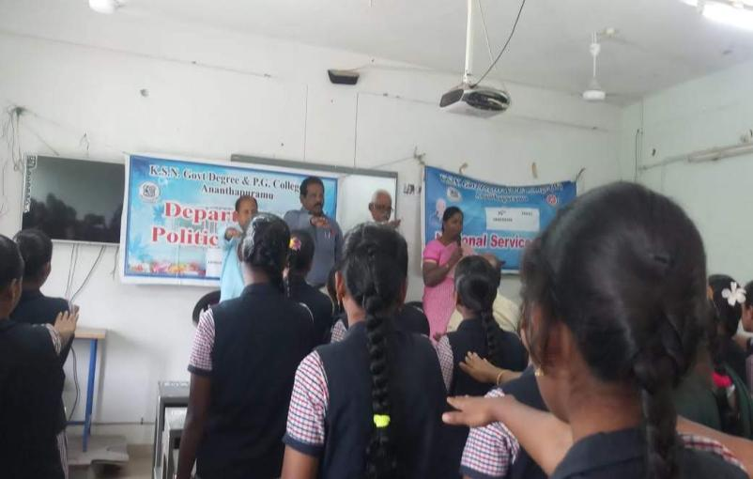

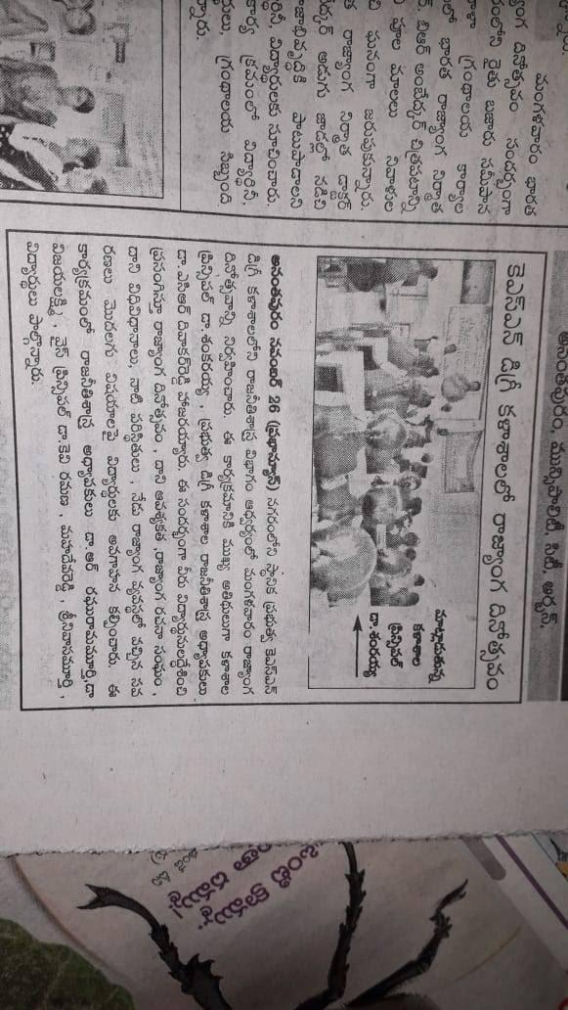

**NSS VOLUNTEERS PARTICIPATED AND CONDUCTED A RALLY ON 1-12-2019 CONDUCTED BY YOUTH WELFARE DEPARTMENT AND DISTRICT MEDICAL AND HEALTH OFFICE**

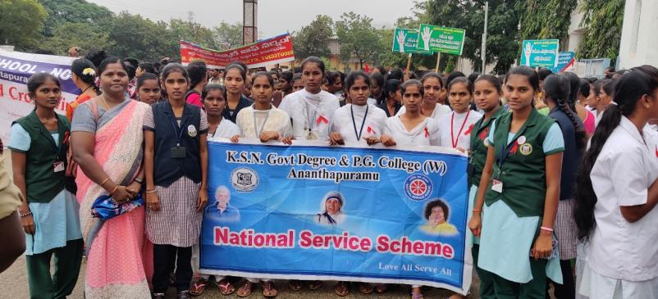

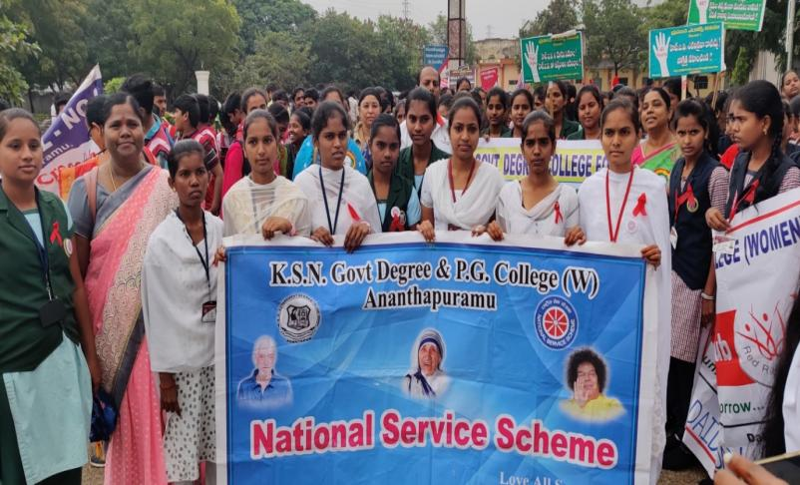

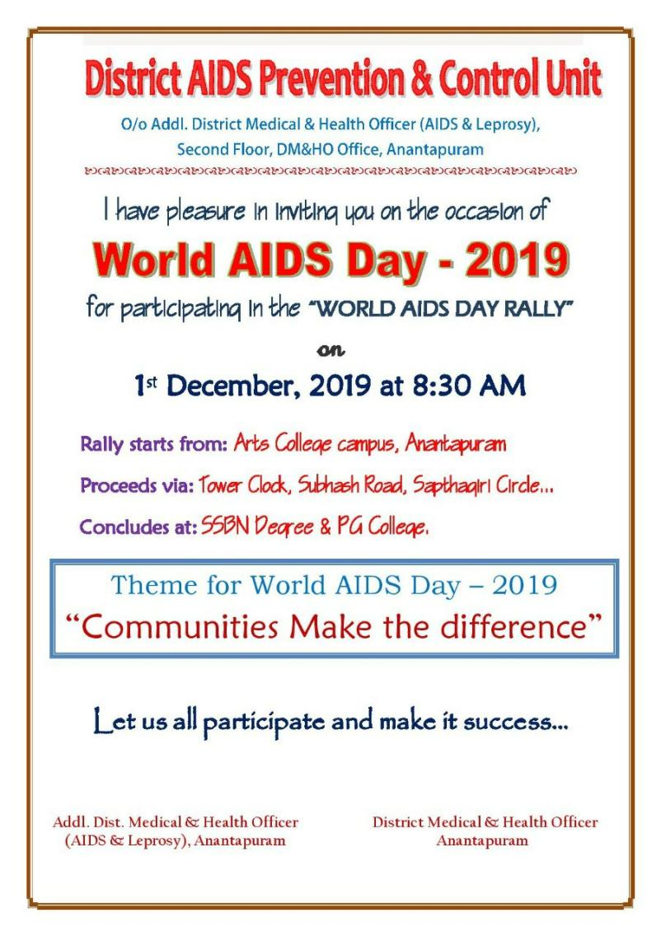

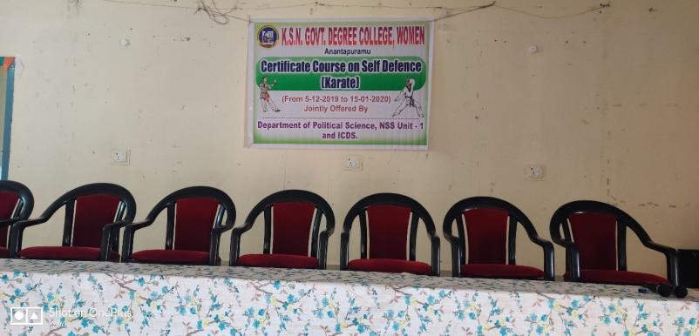

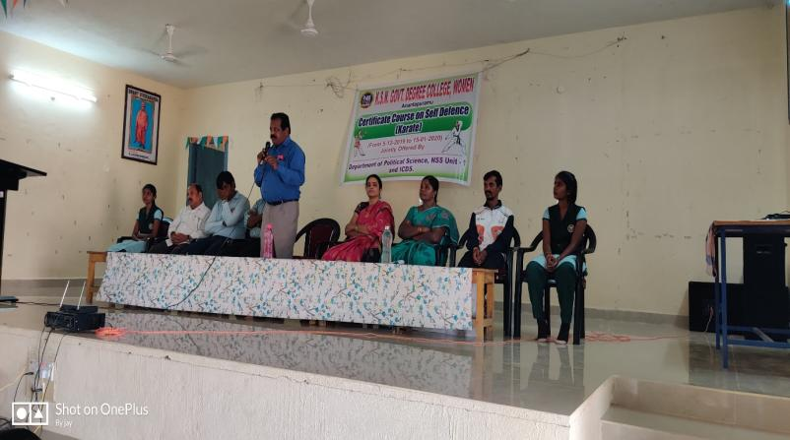

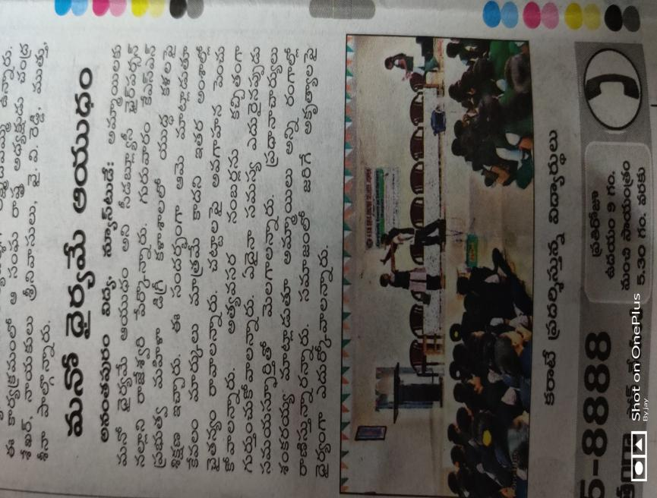

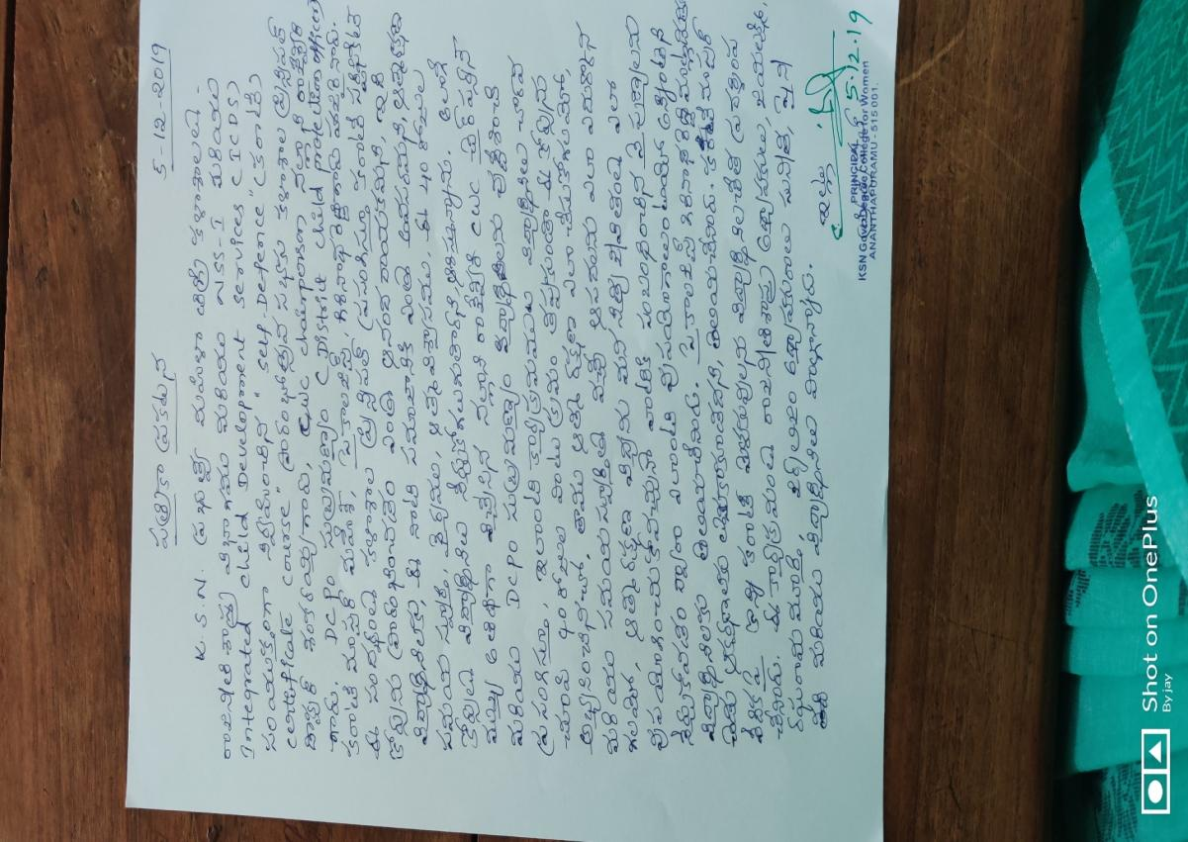

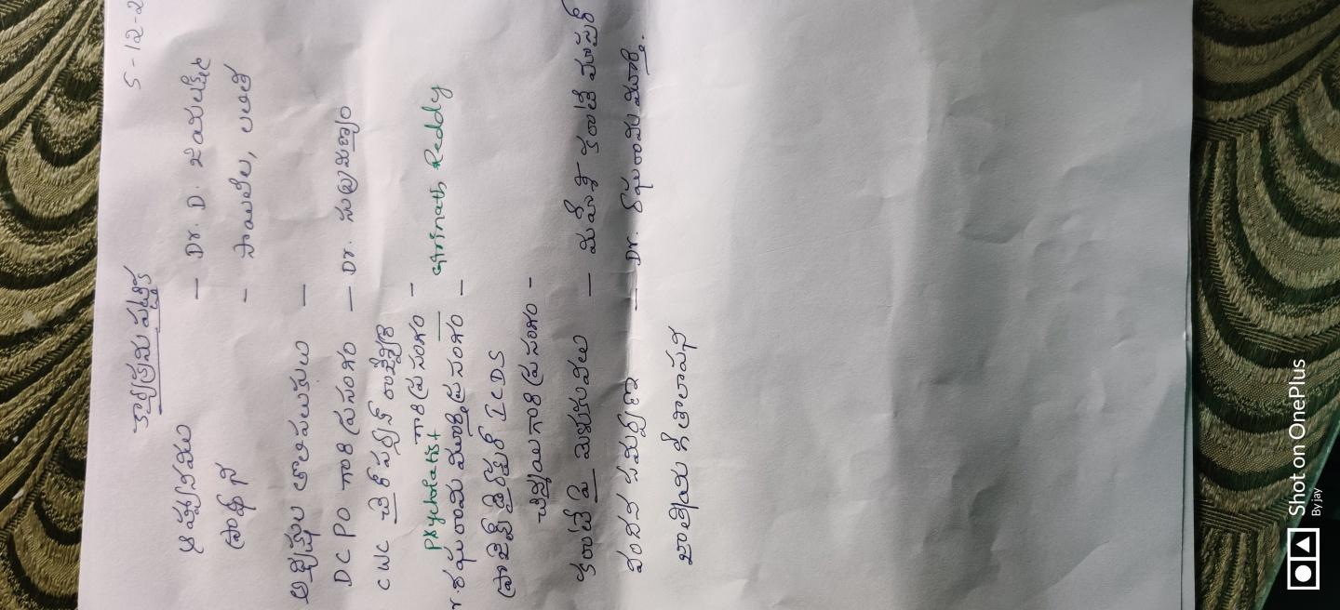

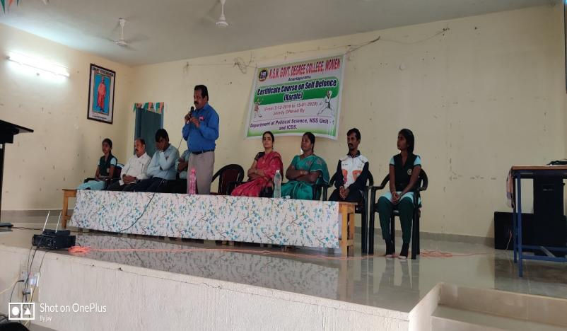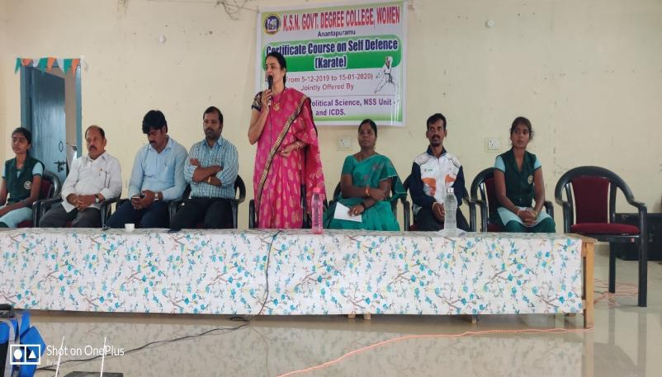

**CONDUCTED 10th NATIONAL VOTERS DAY ON 25-1-2020, IN THIS OCCASSION CHIEF GUEST OF THIS FUNCTION ARE LAKSHMNA REDDY, Dr. Amaranath, SMT. SREEVIDHYA MPDO AND AISF STUDENTS FEDERATION, CONDUCTED BY JANAVIGNANAVEDIKA**

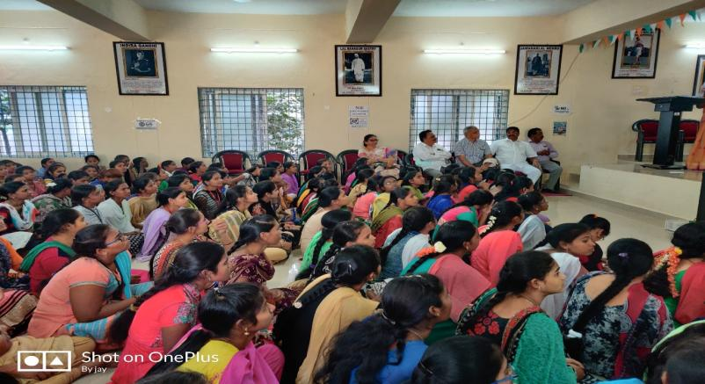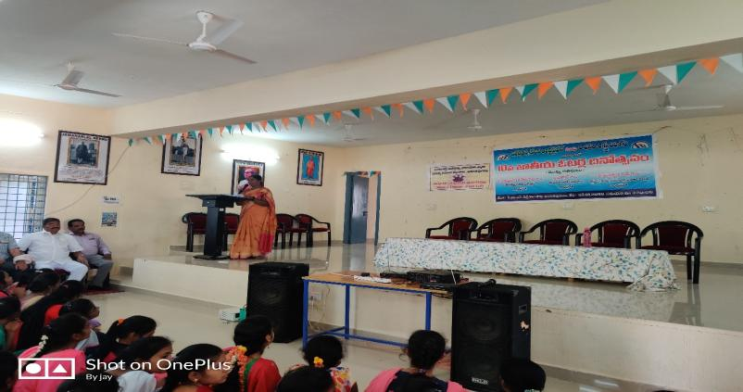

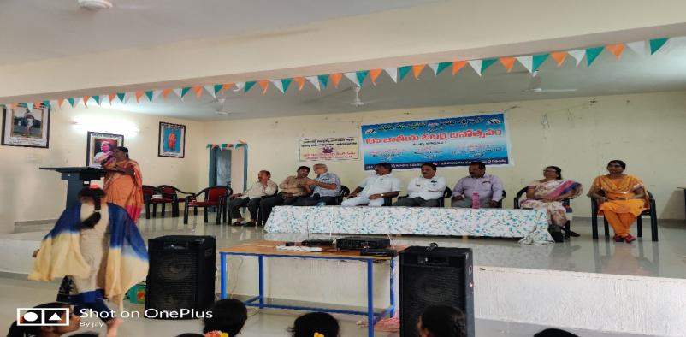

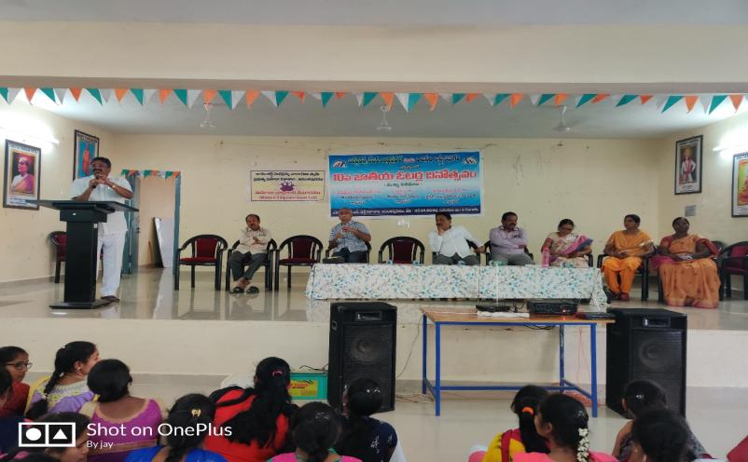

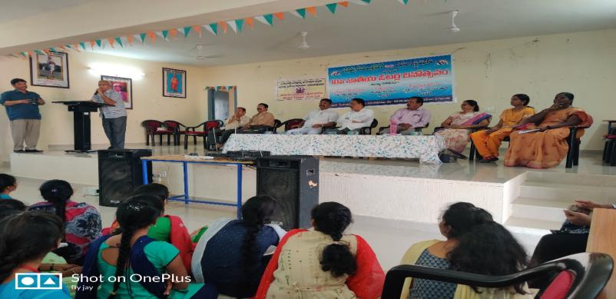

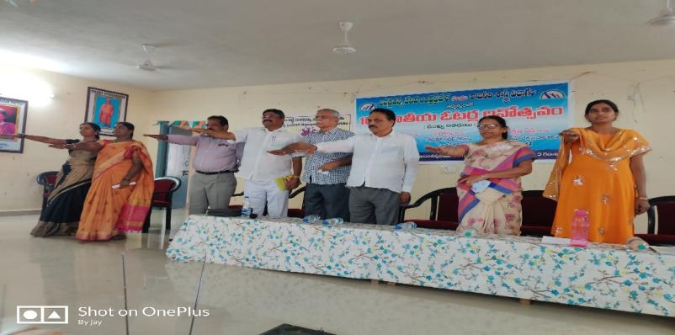

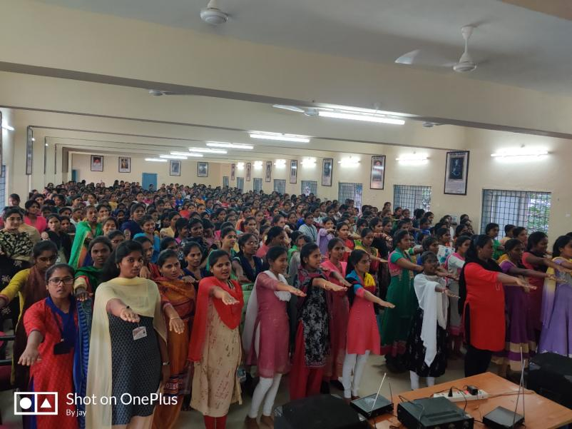

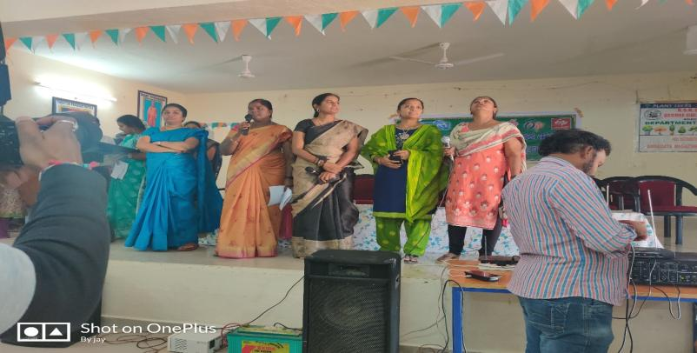

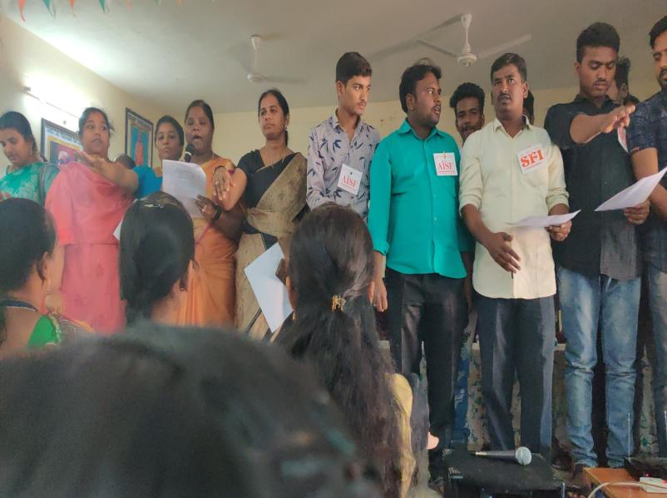



**ROADS AND SAFETY AWARENESS WEEK CONDUCTED ON 8-1-2020**

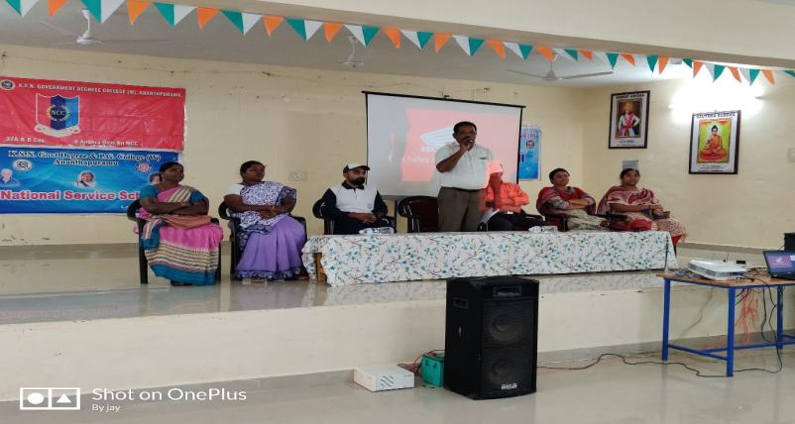

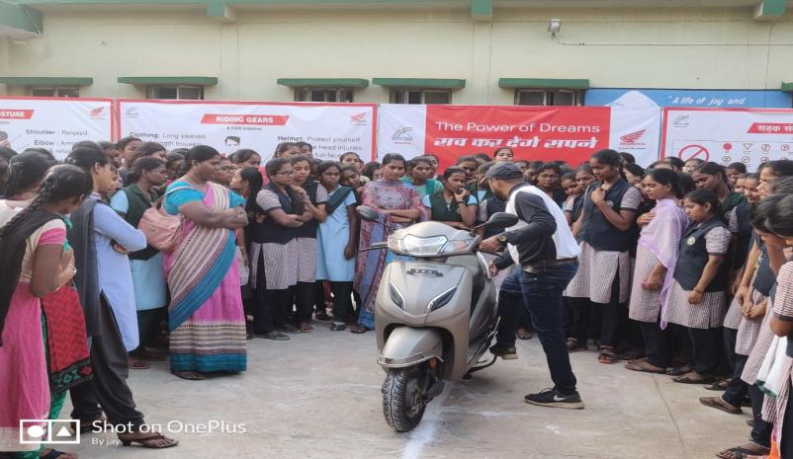

**INTERNATIONAL GIRL CHILD DAY CONDUCTED RALLY ON 24 – 1 - 2020**

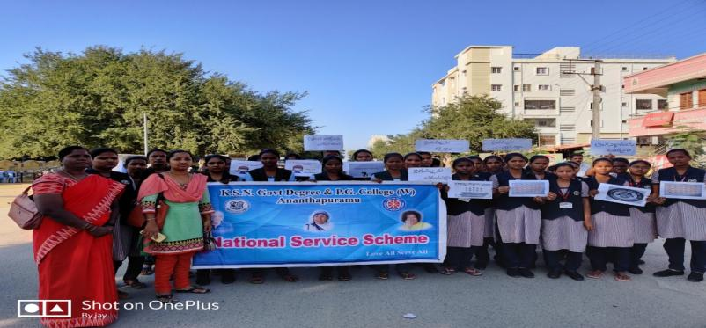

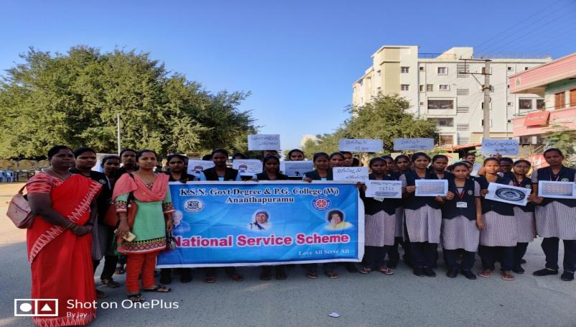

**Conducted awareness program on women protection acts. Todays Guest- Smt. Nallani Rajeswari CWC member, Ananthapur and circle Inspector Purushotham Reddygaaru on 31-12-2019**

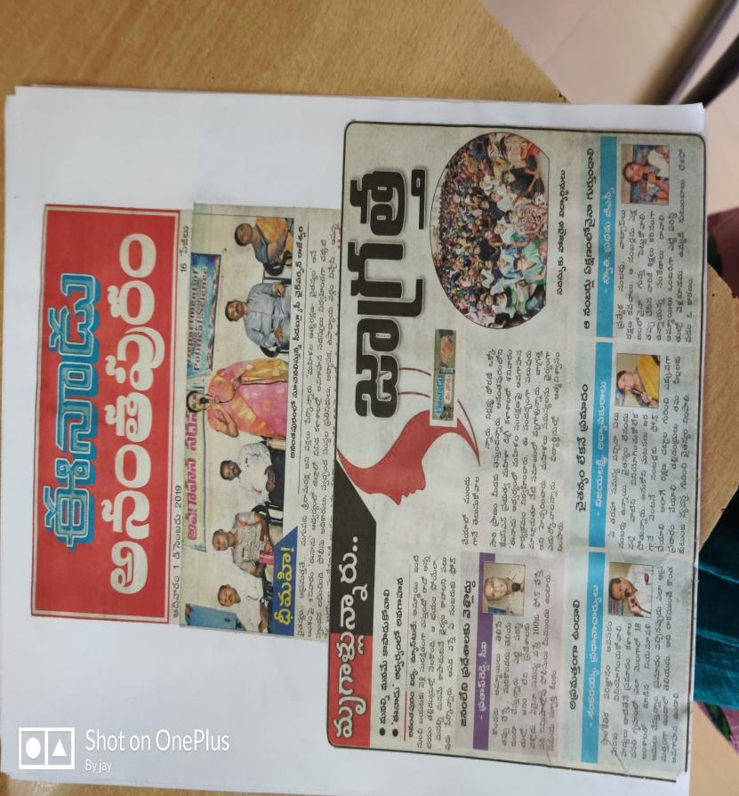

**NSS VOLUNTEER K. SIREESHA III BSC STUDENT PARTICIPATED 10 DAYS NATIONAL INTEGRATION CAMP AT BANGALORE**

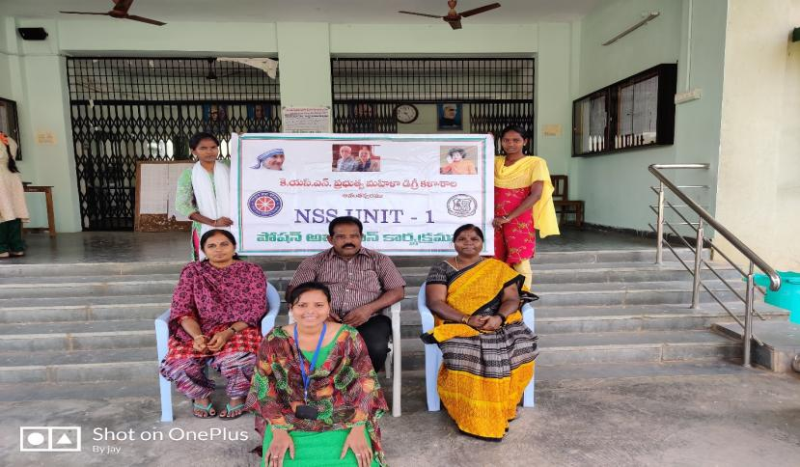

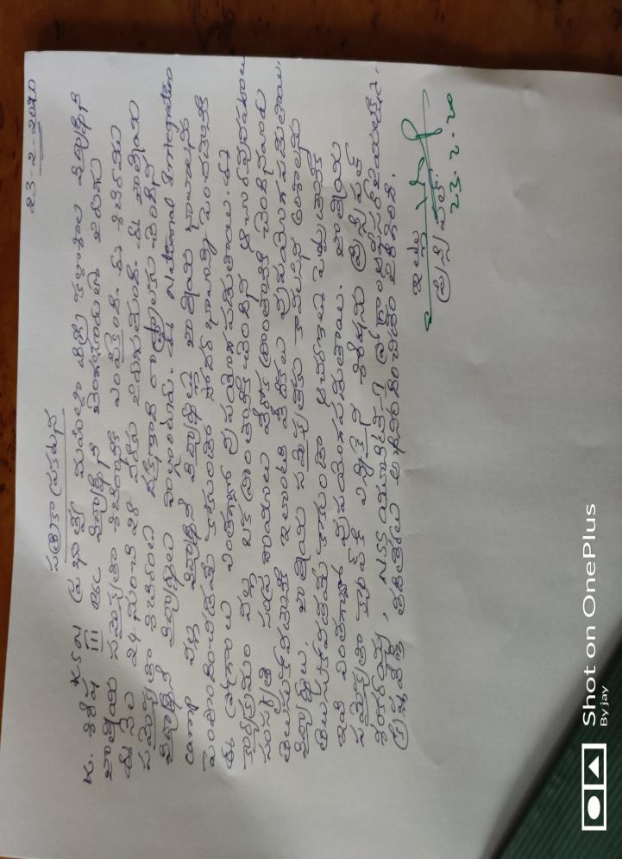

**DURING COVID-19 CRISIS FRUITS AND VEGETABLES WERE DISTRIBUTED TO POLICE AND OLD PEOPLE ON 13-4-2020**

